NAFAANA
people name Nafaana (sing Nafaan)
to others Banda, Pantera, Kapantera, and Fantera
language Nafaanra
home area Nafantra about 940 sq km
other local peoples a few Fulani herdsmen keep cattle for Nafana owners
main towns Sampa (population 2000 11,348; 1984 6,469; 1970 3,906)
Banda (including all of the Banda villages 2000 ????)
chiefs Sampa - Samuel Kwame Siey (Regent)
Banda Ahenkro - Nana Okokyiridom Kwadwo Sito I
principal gods Jafun - chief shrines at Sampa and Duadaso 1
Kamsanpreɛ - chief shrine at Banda Ahenkro
main occupation farming
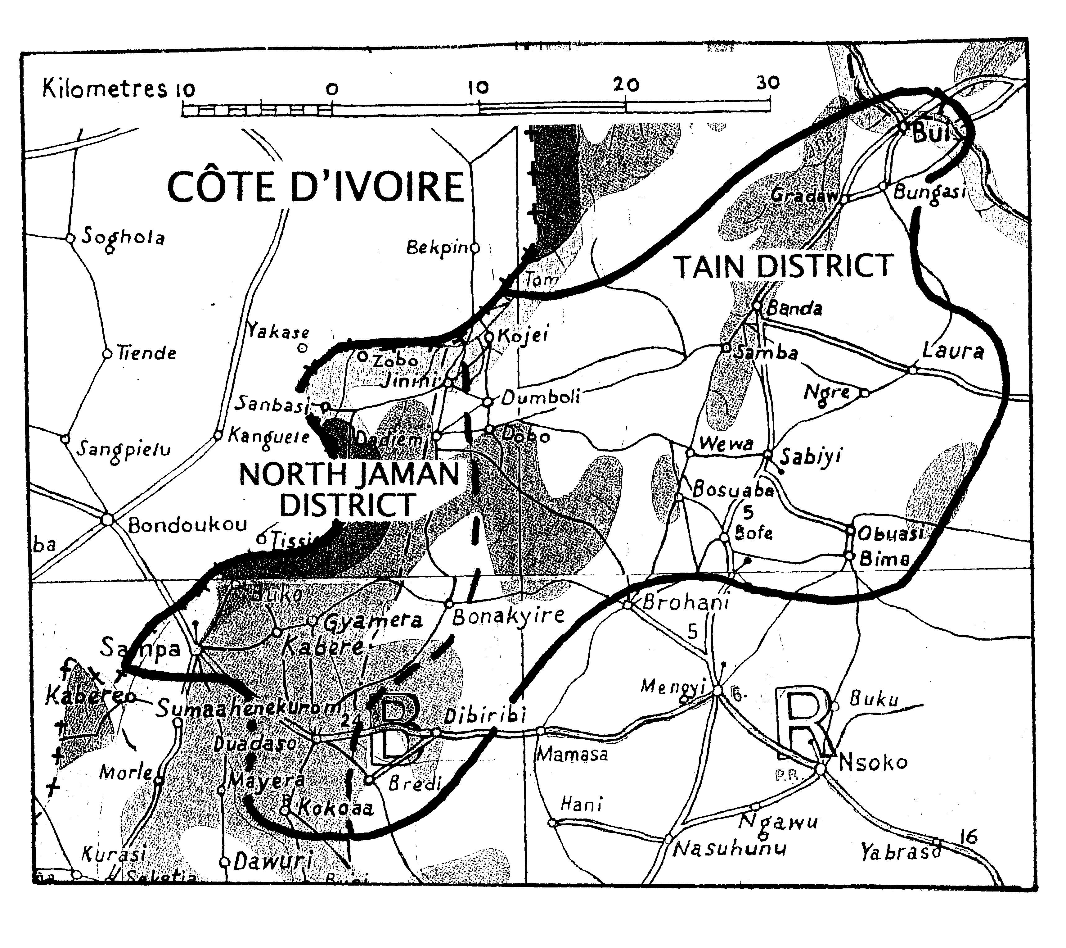
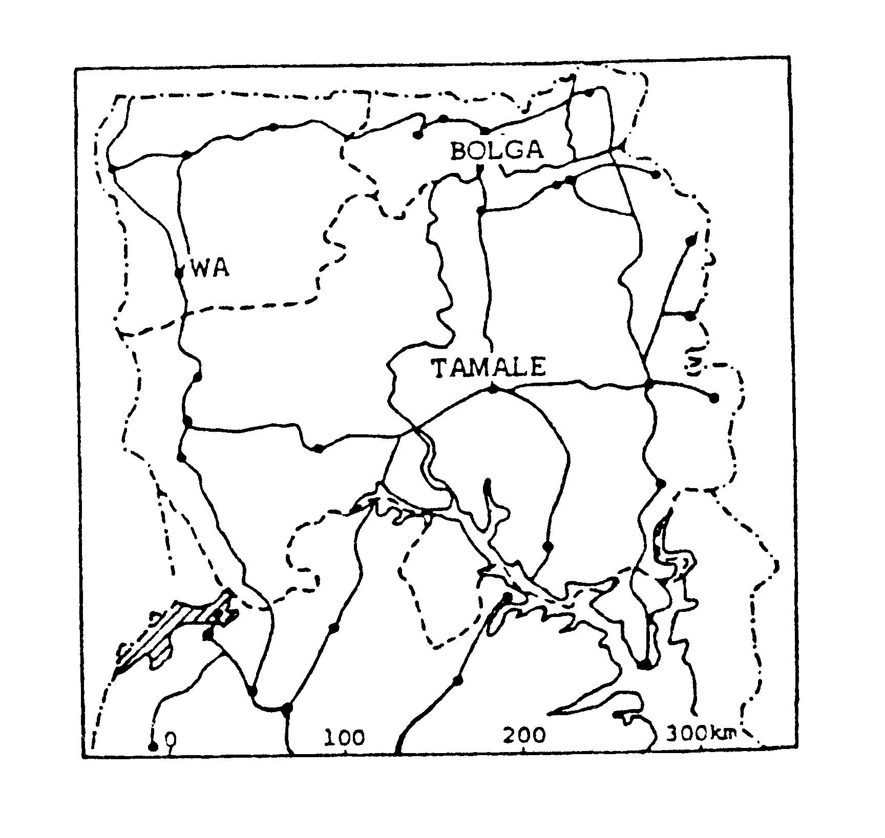
location Nafantra lies along the Ivory Coast border, part in Tain District, part in North Jaman, both Brong Ahafo; north-west of Wenchi. Sampa and 10 Nafana villages are in Jaman North District (District offices at Sampa); Banda and some 20 northern villages are in Tain District (District offices at Nsawkaw).
Sampa area Sampa town had 11,348 inhabitants at the 2000 Census, and has a town council with offices in the town; there are some 10 Nafana villages nearby, all in Jaman North District.
Banda area Banda central is a cluster of 8 separate villages. They are Ahenkro, where the Traditional Council has its ahemfie; Kabrono; Saase and Kankam, which are Muslim settlements; Dompofie, Gbao, Makala, and Samwa. All have their own boreholes, most have primary schools, churches, mosques, and a few shops.
CAN A SMALL FARMER ESCAPE FROM THE SUBSISTENCE MODEL?
Kwaku Kyeremeh interviewed by Peter Barker, on his attempt to become a poultry farmer
Agriculture using modern methods is on the JHS syllabus in rural schools and GES provides good text-books, but not many students choose to study the subject; those who do, and who want to become farmers, find themselves trapped in the centuries-old rhythm of subsistence farming, using axe, cutlass, and hoe. 32-year-old Kwaku Kyeremeh of Banda Ahenkro is one of them. He discovered that learning theory in the classroom was not enough.
In 2004 an agency of the Ministry of Manpower Development and Employment ran a six-month course at Wenchi Farm Institute, to teach 106 would-be poultry farmers how to raise chickens by modern methods. Kwaku was one of 97 who heard about the course on the radio and completed it successfully. After that it cost him very little to build two thatched animal huts, 17 x 3 m, with mud and wood, and he was ready to receive chicks. But though he farms five acres he had no capital to buy the chickens. His style of farming could not generate enough income to support his children (one child in JHS and three in Kindergarten and Primary) and have enough left over to save.
The cost of 50 chicks at C75 in 2008 looked minimal but Dormaa Ahenkro, the nearest source, is 140 kms away from Banda and together with the bill for medication it was well beyond Kwaku’s ability to go and buy them.
What of the alternatives? Piglets and cashew-nut seedlings are available from Wenchi but had he tried to raise pigs or make a cashew-nut plantation he would still have found the initial cost beyond his reach. If a subsistence farmer has to support several children, he cannot save up the capital he would need, however hard-working he may be. Banks and credit unions provide loans for those who have succeeded in saving, but those at the bottom end of the scale have no hope of finding micro-capital.
If Nafaantra is to enable its educated youth to make modern agricultural methods work on a significant scale, it needs two things: first, many dedicated and enthusiastic teachers of agriculture to make this subject popular in school; and then it needs a local provider of micro-finance. Could an NGO help traditional authorities, churches, and Islamic leaders to set up such a scheme?
POPULATION
Table 1 NAFANA - COMPARED BY YEAR (not listed in 2000 Census)
 | 1984 PLR estimates | 2003 Ethnolog estimate | our 2010 estimate
Brong Ahafo | 21,900 |  | 49,300
Other 6 S Regions | 2,000 |  | 11,700
GHANA Total | 23,900 | 61,000 | 61,000
CÔTE D’IVOIRE | 15,000 |  | 30,000
LANGUAGE AND DIALECTS
Nafaanra (also named Banda, after the town) is a Gur language of the Senufo sub-group. While no distinct dialects are named, there are gradual variations of dialect from Banda in the north-east to Sampa in the south-west, and across the border to Tamingi in Côte d’Ivoire. A much more distinct dialect is spoken in Kakala, Côte d’Ivoire.
Language use The trade language is Twi, which is spoken by nearly all Nafana. Twi is taught in school and used in church. The Muslim villages of Saase, Kankam, and Jimini speak Ligbi but also understand Nafaanra. Local Fulani herdsmen speak Fulbe among themselves but understand Nafaanra and Twi. Several churches use the Twi Bible although the Nafaanra New Testament is available.
LITERACY/BIBLE TRANSLATION
started by GILLBT | Literacy | NT printed | OT started
1972 | Primers and b’klets on health etc were done in the 1970s; 1,000+ students were formerly enrolled | 1985 | 1992

ORIGINS AND HISTORY
Most of the following is 1986 material (based on EO and KA). As the traditional authorities of Banda Ahenkro and Kabrono have different accounts of the history we have asked for their written accounts to be submitted and included here.
The people of Banda and Sampa migrated from Kakala in Ivory Coast. This migration probably took place some time after 1700 and was prompted by tribal wars and slave raiding. There are various different traditions of origin; people in Debibi and Hani also speak Nafaanra, and claim to have come from a hole in the ground at Begho; the latter claim they were the first inhabitants, whereas the Banda and Sampa traditions say Ligbi or Sase people (Muslims) were already in the area.
See Appendix 2 for KA’s list of 14 chiefs of Banda Ahenkro and 10 imams of Banda. Also for a list of 18 chiefs of Sampa.
A tradition passed on by the Omanhene, Nana Kofi Dwuru, and recorded by Amenyaw in 1965, says that, when the chief, Zie, died in Kakala, Kra Longo (Kralongo), succeeded to the stool but left soon after because, before he could make the customary choice one of his uncle Zie’s wives, another reelative of Zie had already made pregnant the woman he wanted. The migrants settled in three places: a first group at Taminge or Tampi; a second group under Kra Longo who left Tampe and settled at Makala some 15m (25km) SW of present Banda, then moved to Kabrono near Ahenkro; a third group under Sieyono (Sienyono kpɔɔ = big) settled at Sampa. See Appendix 1 for lists of chiefs: Banda (KA), Sampa (SKS).
One tradition holds that the Gyamera clan were the fore-runners, and called Kra Longo and Sienynonokpɔɔ to help them in fighting the Kolossa whom they succeeded in defeating.
Several traditions suggest that the migrants included a group of Muslim traders who spoke Ligbi and were active at Begho.
Owusuh listed eight chiefs of Banda from 1730 to 1890 They were involved in a series of conflicts and alliances which frequently turned out badly for them. Osei Kwadwo, Asantehene from 1753 to 1781, forced them into an alliance, and they fought for Asantehene Osei Bonsu against both the Fantis and the Gyamans. On their way to this war they had to go to the coast and refused the chance of a sleep-over in Kumasi, so they were called in Twi “Ba nda” (“they did not sleep”) and that became the name of the town.
To escape a heavy fine levied on them by the Ashanti for alleged cowardice in battle, Nana Wulodwo fled with his people to Bouna, now Ivory coast, where the Bounas routed them and inflicted heavy casualties.
Reconciled to Ashanti they returned to Banda but offended the Gyaman and fled to Longoro to take refuge among the Mo. There they allied with Ashanti against Nkoranza, only to be crushed by Nkoranza when Ashanti power declined. They then fled again, this time to Akumadan and Bui. A treaty with Britain, negotiated by George Ekem Ferguson in 1894, finally brought an end to their wanderings.
AUTHORITY
Village chiefs are selected by heads of families including the royal family; village chiefs owe allegiance to the paramount chief at Banda.
Though their language belongs to the Gur family centred in the 3 northern regions rather than Akan, the Nafana use the familiar Akan titles for chiefs (Omanhene, Krontihene, etc) and chiefs sit on stools rather than skins.
Banda
Pehzoo, the fifth chief after the founder Kra Longo, changed the rule governing succession to the paramountcy. Up to his reign all chiefs of Banda had come from the Oyoko clan, but he declared that his personal assistant Petele should succeed him, and Petele was in fact enstooled. Since then the paramountcy has alternated between the Kabrono family to which Petele belonged and the Ahenkro family of the founder Kra Longo. A case contesting this arrangement was concluded in 2005.
Sampa
[more infomation needed]
INHERITANCE
Inheritance is matrilineal; a man inherits from his mother's brother. A year or more after the death, the head of family calls a meeting at his house for the purpose of announcing the heir; the deceased's property is inspected, then handed over to the heir. Drinks are bought by the head of family and by the heir. The ceremony is known as krɔlie.
DAILY LIFE IN COMPOUND, FARM, AND VILLAGE
Compounds 15 to 25 people used to live together in a compound of square or rectangular rooms round a central courtyard; a man may share the compound with his wife or wives and sons and daughters, or with his sister(s) and sons and daughters, or both. All small children stay with the mother, but boys stay with the father after a certain age. The number of people in a typical compound has fallen sharply because so many have migrated to other areas; many compounds have derelict, unoccupied rooms.
Farming and hunting Farms are up to 5 km from the village; farmers hold their land in trust for the traditional authorities of the area. They strictly observe the traditional day of rest, Sumbɔɔ Ajuan, every 6 days.
Main cash crops include yams, cassava, cashew nuts, and calabashes. There is a commercial cashew-nut processing factory with some 50 workers at Nsawkaw and most of the local production goes there for export through southern Ghana.
Cotton was grown in the 1970s but little is grown now. Scores of tobacco drying kilns with their metal ducts are evidence of an industry which has collapsed as the world has abandoned smoking for health reasons.
Crops for local consumption include the above, also corn, guinea corn, millet, beans, groundnuts, and okro. During the rainy season there are fenced gardens round the houses where they grow tomatoes, cocoyams, alefu, and corn; shea nuts are collected in the bush.
Bush-burning in the dry season to assist in hunting grass-cutters and other small game is illegal but it is a tradition going back for many generations. There is effective control within 5-10 km of towns like Berekum and Sunyani, where people can be arrested for carryng matches to their farms, but the two police-stations in Nafantra are helpless to identify those who started the fires, so there is no control. Teak electricity poles and any new farming development are in danger of destruction by this random burning, resulting in frequent electricity cuts and loss of valuable cashew-nut plantations.
It will require a serious and united campaign by traditional authorities in cooperation with all churches, mosques, and other community groups to change the mentality and give hunters a conscience about the havoc they cause.
Fishing (2008) Few Nafana fish in the Black Volta; but there are small Ewe communities, perhaps 300+ at Bui and nearby sites on the river. Ewe women fry and smoke the fish, then take it to markets in Banda, Nsawkaw, and Seikwa to sell.
Crafts A few individuals make baskets and mats. There are carvers who make mortars for banku abetiɛ (made from corn and cassava dough) and pounding sticks. Pottery is made in Adadiem and Dobor.
Markets are held once a week, in a 7-day cycle: Sampa on Monday, Banda on Tuesday, Sase on Friday morning (finishing at 11.00 because Sase is a Muslim village). Most villages have markets for the sale of calabashes and calabash seeds, onions, kola, salt, and agricultural produce. Traders come from outside the area with salt, bananas, tomatoes, and second-hand clothing. A few Hausa traders come by bicycle to sell cloth and charms.
Sampa is the major market, rivalling those Techiman and Wenchi. People come from Côte d’Ivoire to buy there, and get good value for their CFA francs.
Water In 1986 water was mostly carried home from rivers, dams, and wells. Many old government bore-holes were out of use; the Catholic Church rehabilitated some and made some 60 new ones. By 2008 nearly every village had a borehole, but frequent breakdowns lead to water shortage in the dry season. Sampa has a piped water system but it is subject to breakdowns.
Fuel In 1986 firewood was easily collected in the bush, but now more charcoal is used.
EDUCATON AND HEALTH
Education
(NOTE: KG kindergarten: PR primary: JHS junior high: SSS senior secondary – enrolment figures for most private schools are not available)
SAMPA | No of Govt schs | students | trained t’chers | untrained | Private schs
Kindergarten | 21 | 1,726 |  |  | 9
Primary | 22 | 4,956 |  |  | 9
JHS | 17 | 2,596 |  |  | 5
SHS & Tech | 2 | 679 |  |  | 1
total |  | 9,957 | ? | ? | 1

BANDA | No of Govt schs | students | trained t’chers | untrained | Private schs
Kindergarten | 11 | 896 |  |  | 9
Primary | 14 | 2,042 |  |  | 5
JHS | 7 | 535 |  |  | 6
SHS & Tech |  |  |  |  | (58 students) 1
total |  | 3,573 | 276 (40%) | 454 (60%)

Thus neither Sampa nor especially Banda have nearly enough SSS places to receive the annual output of JHS children. For instance in 2007 just one of the 13 Banda JHS saw ?? students pass the JHS, of whom only ?? got a place at Banda SSS.
Until 2006 the Banda area had no SSS. Then the chiefs of Ahenkro and Kabrono, and the local community, raised money and appealed to Pioneers, a Christian NGO, to establish a secondary school in the old agricultural project premises at Gbao. Pioneers provided two expatriate staff and funding for 5 Ghanaian staff and one National Serviceman. The site is isolated and the premises need extensive renovation, yet there is a renovated borehole on site, and student enrolment is encouraging – there are now 26 in Form 2 and 32 in Form 1. But before the Ghana Education Service can take responsibility for the school the community must raise money to bring it up to the required standard.
Pioneers have a long-term commitment to this school and it is likely that their role would continue if GES were to adopt it, and it is hoped this will happen.
Health
Sampa has a 65-bed Government Hospital with 3 doctors (one Ghanaian and 2 Cuban volunteers).
Banda has had a Rural Clinic with a medical assistant since the 1990s. The intervention of Pioneers, the Christian NGO, enabled the Ministry of Health to upgrade it to a Banda Health Centre in 2006. The medical assistant was replaced by a Ghanaian Pioneers doctor. Her staff consists entirely of beginners in training at Banda on the job. Some (number?) are training as nurses, and (?) TBAs are training as midwives.
Rural Clinics were first opened in the 1950s; Community Health Posts (CHPS) more recently. There is now a Rural Clinic at Sabiyi. The nearest hospitals are the Methodist Hospital at Wenchi (about 75 km), and the Catholic Holy Family Hospital at Techiman (over 100 km) which despite the distance is very popular.
The commonest diseases are malaria, anaemia, respiratory tract infections, worms, gastro-intestinal conditions, and hypertension. Black fly causes great discomfort especially in the rainy season, but a Community-Based Surveillance Volunteer regularly distributes Invermectin for protection against it; the black fly has not yet been controlled at source in its breeding-places.
HIV/AIDS afflicts 6-8% of the population in Jaman North District, which is above the 5% epidemic rate and compares unfavourably with the national average of under 3%. Reasons for the high rate in Nafana include the long common boundary with Côte d’Ivoire where HIV/AIDS is prevalent; and the high rate of seasonal migration to Sefwi to work on cocoa farms, with consequent separation of spouses for months at a time. The growing cashew nut industry is another source of infection as it attracts long-distance drivers and seasonal sex workers.
Banda and Sampa have police stations
Transport Daily lorries run independently to Wenchi from both Banda and Sampa between Banda and New Longoro; but the only regular direct lorry between Banda and Sampa is on Monday when Sampa has its weekly market. Lorries run to Techiman on market day. [update]
Nafana Development Committees were founded in Sampa [and Banda???] in 1979 to unite and develop the area. The Sampa committee raised money to establish and run the Nafana Secondary School until Ghana Education Service took it over. After this initial activity there was no follow-up, and the Committees are no longer functioning effectively.
MIGRATION (1986)
Reasons for migration include the quest for secondary or higher education, the desire to learn a trade or earn a salary, and the fear of witchcraft at home. Many migrants work as carpenters or fitters, or as labourers on cocoa farms; some start their own farms. Nafana communities are found in the Ivory Coast, Brong Ahafo, and Ashanti, for instance in Adamso, Sekotia, Berekum, and Kumasi Mbrom; many Nafana women have taken up prostitution in such places.
Migrant communities often appoint the oldest person as headman; individuals aim to build a house at home in Banda before returning there to live.
Many migrant traditional worshippers find accommodation in Muslim compounds and become Muslims while away from home.
RELIGION
estimated %ages | Traditional | Muslim | Christian | No religion
1986 | 92 | 4 | under 1 | ?
2008 | 20 | 45 | 20 | 15
Traditional Religion (SKS)
God is called Nyiekpɔɔ or Nyiekpon (nyiɛ = soul, Twi kra; kpɔɔ = big), and Nyiɛkpɔɔ is recognised by Christians as the supreme God of the Bible and of Christian eɩperience.
Traditional believers know that he created everything, but they include stones and other objects revered as lesser gods. SKS explained, “We couldn’t get in contact with Nyiɛkpɔɔ so we looked at the stone or effigy to represent God. We brought coal or goat to that stone and made our requests. Nyiekpɔɔ is mentioned in prayers to ancestors but no worship or prayer is offered directly to him.
A cement sɛɛn stands in the Ahenkro ahemfie but traditional believers refer to it as Nyiɛkpɔɔ, thus blurring the distinction between sɛɛnlɛ or gods and the supreme God.
Traditional religion has declined dramatically over the past 30 years. There has been no direct confrontation between Christianity and the old religion, but the former gods have gradually fallen out of use as Christian belief has spread; priests die and have no successor. The following account is therefore written partly in the present tense but also in the past tense.:
Earth Every town or village has its own shrine for tra or Earth; these have no personal names, but are called "Banda Ahenkro Tra", "Sampa Tra", and so on. The priest of a tra is a trafun (plur trafɛɛlɛ) or trapɛɛifun. Earth-shrines are often in the form of a heap of stones under a tree.
Regular annual sacrifices, for instance a goat and 7 fowls, are offered to tra before bush-burning, with the prayer that the fire will not hurt anyone, although all bush-burning is illegal. An individual whose crops are stolen may lay cola on the ground and ask the help of tra in private prayer.
Sɛɛn (gods) In 1986 Owusuh listed 22 gods (sɛɛnlɛ sing sɛɛn or nyiewɛɛ sing.nyiwaa); named by the elders of Banda, Debibi, Hani, and Sampa, between 4 and 8 in each town, none of them mentioned in more than one town. In each town one particular god was the most powerful one, usually the war-god – Sanya Kupo in Banda, Boono in Debibi, Kwasiawufoɔ in Hani.
Priests are sɛɛnpɛɛrifun (pɛɛri = offer, fun = person, therefore a person who makes offerings to the god.
Soothsayers, called to help a sick person, might say that he had offended a sɛɛn and the priest of the sɛɛn would say Me sɛ pɛɛri wɔ = I am going to make an offering.
In Sampa, Kanamgbele was the most powerful, and today it is the only god which continues to have an active priest and shrine.
Jafun (= powerful) is recognised in Ahenkro, Kabrono, and elsewhere, particularly in Wewa. The shrine is made of moulded mud, with a stone on top. When a priest dies his son is expected to succeed him.
The Wewa priest of Jafun died in 1970, but his son did not succeed him, and instead became a member and now a pastor of the African Faith Tabernacle Church. Another priest of Wewa died in 2003 and they found a successor.
The Hani people say two gods, Kwasiawufoɔ and Bosom-hene, were brought with them from the hole at Begho; three other gods, Taa Fofie, Taa Kese, and Taa Kwasi, were obtained from the River Tano, hence the name Taa. (EO)
The Sampa god Sai was the blacksmiths' god; the Banda god Nyietwara (mentioned by Anane but not by Owusuh) was the thunder god, who killed wrongdoers by lightning; Anane mentioned a constructed shrine with a small pot of water on it. People who had articles stolen came to the priest of Nyietwara seeking the punishment of the offender; the priest might arrange for gong-gong to be beaten to call for return of the stolen goods, and if they were returned the client might bring an offering to the god. (SKS)
Lopom (= elder) was a god in both Sampa and Banda. In Sampa it was located in a room with a raised platform, and was an object probably moulded from mud, placed on a brass pan, and black with the dried blood of innumerable fowls and goats sacrificed on it. It was still an active shrine when SKS left Sampa in 1960, but when he next came home in 1976 the priest had died and it was defunct. (SKS)
In Ahenkro it was the house of Kunkununkun, the original owner. Kwaku Dapaa, the last owner, is still alive but is aged and does not have the energy to function effectively. The youth in the house have moved into Christianity or Islam: one is a pastor, another is an Imam. Consequently Lopom is practially defunct. (DK)
Bisibore was a war-god, called on to help whenever Banda went to war. The former priest is still active as a herbalist. (SKS)
Informants in Kabrono mentioned five other sɛɛn who belong to individual families in the community, but work on behalf of all comers:
Gyagbina, for protection in war, last used over 100 years ago;
Gyakari, after whom some men are named;
Guli, Kwaku Fili, Maase, who are said to perform the typical services of protection from witches and response to other personal problems, in return for promises of fowl, sheep, cola, wine, etc, which may be given annually. (PB)
Owusuh's informants in Banda distinguished between stone gods or bo some which are immovable, and adunsini, medicines or fetishes, which may be carried to war.
Family and personal gods or “fetishes” Anane said in 1985 that each head of house had at least one family god or sɛɛn; and that individual might also have sɛɛnlɛ. Some went as far as Gonja to get a god or fetish.
Ancestors are consulted for direction on numerous occasions by a prayer with libation. Such prayers begin, Waa Nyiɛkpɔɔ na tra dali = we are begging Nyiɛkpɔɔ and the Earth. When FGM was finally abandoned in 2007 it was thought necessary to placate the ancestors, and in Ahenkro the Krontihene slaughtered a cow at the ahemfie. (SKS) Those who do not respect their ancestors or use the services of diviners or priests to present their needs to them are thought of as taabuusi(foɔ), people who do not know their home.
Diviners and herbalists (chilefɛɛnlɛ (sing. chilefun / tuwefun), for many purposes, including identification of witches. One who wants to be a herbalist may ask a gifted man to show him the trees and leaves that are used, and may pay for the information and later become a herbalist himself. Such people need some sort of spiritual power to do this work. (SKS)
Witchcraft People are no longer accused publicly as witches, but the belief in witchcraft is still held privately. A witch or wizard used to be buried in a shallow grave outside the town with thorns in the grave; no coffin was used. A wizard used to be dragged to the grave by a rope tied round the legs. (SKS)
Various festivals are kept in Nafana towns, with different names in Banda, Debibi, Hani, and Sampa. There is a yam festival, festivals in honour of particular gods, and festivals for the stool and for departed ancestors (see chapter on Festivals)

Christianity - CHURCHES IN NAFANA AREA [outline for you to complete]
c = congregation (number), p = pastor, priest, b = church building
 | AFT | Apos | Cath | CA A | Meth | Pent | Presby |  |  | msq | pray pl | imam
TAIN DISTRICT
Bui village camp
Bungasi
Gradaw
Ahenkro
Kojei
BANDA
Kabruno
Sase
Kankam
Dompofie
Gbao
Samwa
Makala
Dumboli
Ngre
Dobor
Wewa
Sabiyi
Bosuaba
Bofie
Obuasi
Bima
Debibi
Bredi
congs 1986 | 8 |  | 16 | 1 | 2 | 4 | 18
pastors 1986 | 7 |  | 1 | 1 |  |  | 1
buildings 1986 | 3 |  | 14 |  | 2 | 3 | 13
congs 2010
pastors 2010
buildings 2010
 | AFT | Apos | Cath | CA A | Meth | Pent | Presby |  |  | msq | pray pl | imam
SAMPA DISTRICT
Zobo
Jimini
Dadiem No 1
Buko
Bonakyiri
Gyamera
Kabile
SAMPA
Duadaso
Kokoaa
congs 2010
past
pastors 2010
buildings 2010

there are some ten denominations in the area with about 50 local churchesotal population.
The Basel Mission introduced the Presbyterian Church in the area in the mid-1930s. Today there are some 50 denominations in the area. Full members are a minority in most churches.
Islam
The traditions of migration from Kakala suggest that the Nafana were associated with Ligbi-speaking Muslims right from the time they moved from there. However the Muslims have always remained a distinct and separate community, and are still today a small minority. Sase and Kankam are almost entirely Muslim settlements; most villages are mixed settlements, mainly Christian but with Muslim minorities.
There are mosques in Ahenkro, Sase-Kankam, and Gbao. A new mosque is being built in Ahenkro funded by a local leader with overseas financial help.
Muslim Ligbi students at the Pioneers SSS are eager to live on site with their teachers.
The small number of Fulani herdsmen in the Banda area are all Muslim, and worship in local mosques.
A few Nafana Muslims have converted to Christianity, and several Christians have become Muslim after migrating to Berekum or Kumasi.
In the Nafana area nearly all pastors of the African Faith Tabernacle Church, and nearly all Muslim imams, are themselves Nafana.
APPENDIX 1 – LISTS OF CHIEFS [please check with chiefs at Banda and Sampa]
 | Banda Ahenkro (KA) | Sampa (SKS)
Tolee | Kralongo | Sienyonoo Gbaa
.” | Gyara | Gyafla
.” | Sielongo | Sakyele
.” | Sakyi | Sanagya
.” | Pehzoo | Dongi Kyirifo
.” | Petele (Kabrono) | Kaaloh
.” | Habaa (Ahenkro) | Satumbga
.” | Wulodwo (Kabrono) | Satumgba II
.” | Ngunu Dabla (Ahenkro) | Wollie Kwame Gyaabori
.” | Sahkyame aka Wurosa (Kabrono?) | Ahekwaa
.” | Sie Yaw Dwuru (Regent) ? | Kwame Bosuo
.” | Yaw Sielongo ? | Nyuah Kofi
.” | Kwasi Sinapim ? | Kwame Adinkra
.” | Kofi Dwuru (on the stool in 1965)
.” | Kwame Krah
.” | Kofi Sono I
.” | Yaw Sammor-Duah
.” | Kwadwo Adinkra
 | Okokyiridom Kwadwo Sito I  (2008) | Kofi Sono II (paramount) (2008)

[The chief at Kabrono in 2008 was ??]

APPENDIX 2 – LIST OF IMAMS (KA)
Yahaya Barima
Sahedu (Seidu) Banda
Sahedu Banda
Allasani Banda
Mahamudu Banda
Amadu Banda
Mahamudu Banda
Amadu Banda
Leho Sina (Assa)
Barima Banda

SOURCES USED AND OTHER CONTRIBUTORS
K Amenyaw Traditions of Banda, IAS, Legon 1965 (unpublished); Top Facts Press, Tafo Nkyiase, Kumasi, 0244 647235, 35pp, no date. (KA)
Isaac Anane-Yeboah (IA)
J M Anane, questionnaire answers, GEC, 1985 and more recent material (JA)
Banda Omanhene and elders
Kabrono Omanhene and elders
Headmaster, Sampa Secondary School
Kumah Yaw Doayah (headmaster Banda JHS) (KD)
Vasco Manje (headmaster RC Primary JSS Ahenkro) (VM)
Robin & Michael (Pioneers: teachers at Banda Sec School)
Sampa Traditional Council Regent, Samuel Kwaku Siey, (SKS)
E S K Owusuh Oral traditions of Sampa, Hani, Debiri, Namasa, Banda, Broahane and Mengye (Menji) -- Brong Ahafo, IAS, Legon, 1976 (EO)
George Ababio (GA),
Kwame Siegbaa, Kwasi Krah, (Dompofie)

FOR FURTHER READING
T E Fell Notes on the history of Banda, 1913, PRAAD Kumasi, ref D 216
H J Hobbs Notes on the history of Banda, 1926, PRAAD Kumasi, ref D 216
W J Pitt The Mfantra, 1925, PRAAD Kumasi ref D 216
Ann B Stahl [details from J M Anane]

